MINUTES
WildResearch Annual General Meeting 2019
Date: February 23, 2019
Location: VanDusen Botanical Garden, 5251 Oak Street, Vancouver, B.C.
Start: 6:00-6:45 PM
In Attendance:
WildResearch Board of Directors: Jay Brogan (President), Angela Bond (Vice President), Courtney Lahue (Secretary), Vinci Au (Director at Large), Kiirsti Owen (Marketing Coordinator), Andrew Huang (Director at Large), Willie Ng (Acting Treasurer), and Myles Lamont (Director at Large) and Melanie Wilson (Director at Large).

WildResearch Members: Chloe Boynton, Alain Boisclair-Joly, Colin Macfarlane, Azim Shariff, Brooklyn Hillman, Stephen Partington, Kelly Sekhon, Quinn McCallum, Jacqueline Huard, Jesse Kemp, Wally Fletcher, Alan McKenzie, Donna McKenzie, Catherine Jardine, Samantha Stapleton, Pip Humphries, Hana Hermanek, Ildiko Szabo, Sofi Hindmarch, Justine Kaufman, and Adrian Kense.

Regrets: Virginia Noble-Dalton (Director at Large).

Welcome and introductions – Jay Brogan
- Meeting was called to order at 18:10 PST
- Welcome: local and remote introductions of board members
- Additions to the agenda? - None

Adoption of Agenda – Jay Brogan

Approval of the minutes from the 2018 agm – Jay Brogan
- Available at: http://wildresearch.ca/about-us/resources/
Motion: to approve the WildResearch 2018 AGM Minutes
Moved by: Donna McKenzie
Seconded by: Kiirsti Owen
Decision: Motion carried unanimously

President’s report
- Presented by President Jay Brogan
- See Appendix A
Motion: to approve the WildResearch 2018 President’s Report
Moved by: Ildiko Szabo
Seconded by: Alan McKenzie
Decision: Motion carried unanimously

Treasurer’s report
- Presented by Treasurer Willie Ng
- See Appendix B
Motion: to approve the WildResearch 2018 Treasurer’s Report
Moved by: Catherine Jardine
Seconded by: Jesse Kemp
Decision: Motion carried unanimously

Committee Reports
- Presented by Committee Chairs: Andrew Huang (IIBO), Courtney Lahue (MSC), and Courtney Lahue (Outreach)
- See Appendix C, D and E
Motion: to approve the WildResearch 2018 Committee Reports
Moved by: Pip Humphries
Seconded by: Hana Hermanek
Decision: Motion carried unanimously

Elections
Andrew Huang – 15 minutes
- The following are WildResearch members in good standing and are nominated for the positions listed on the Board of Directors for 2019:
  - President: Jay Brogan
  - Vice President: Angela Bond
  - Treasurer: Willie Ng
  - Secretary: Courtney Lahue
  - Director at Large: Andrew Huang
  - Director at Large: Myles Lamont
  - Director at Large: Virginia Noble
  - Director at Large: Vinci Au
  - Director at Large: Kiirsti Owen
  - Director at Large: Melanie Wilson
  - Director at Large: Azim Shariff
Motion: to approve the 2019 nominations for the WildResearch Board of Directors
Moved by: Alan McKenzie
Seconded by: Jacqueline Huard
Decision: Motion carried unanimously

Adjournment
Motion: to adjourn the 2019 Annual General Meeting
Moved by: Kiirsti Owen
Seconded by: Alan McKenzie
Decision: Motion carried unanimously

Please join us after the meeting for our 8th Annual Volunteer Appreciation Party from 6:45 – 10:30 PM!

APPENDIX A

WildResearch President’s Report 2019

WildResearch 2018

President’s Report
Some highlights of 2018:
- We grossed over $14,000 from grants and donations.
- We grossed over $3000 from workshops and merchandise
- Over 500 volunteers spent over 3000 hours participating in our programs and committees
- We have 336 members and we didn’t run a pelagic trip this year, which is usually the big membership draw.
We started off the year with a strategic planning meeting to focus the direction of the organization and how we want to get there. We came up with three primary goals: funding, board management, and training workshops. We’ve worked away at these goals through writing grants and paid training workshops, solidifying the boards roles, and offering novel, useful workshops.
In 2018, we offered workshops for biologists and naturalists. Though IIBO, we offered a Beginner banding workshop and, for those that wanted more, an Intermediate Banding Workshop. We offered another Resume Writing Workshop for Biologist which was well attended. We also offered a first, a workshop on QGIS, an analytical spatial program valuable for biological research. And we continued to offer our long standing winter Bird ID Field Trips. We were able to offered these workshops at a fair value with our members in mind and we grossed over $3000 for the organization.
WildResearch’s mission is to build, train, and educate a community that contributes to conservation science. Our programs touch on each of these goals, specifically:
Contribute to conservation science:
IIBO determines the abundance and diversity of migrants that use the Iona Beach Regional Park (hereafter: Iona) as a stopover site; IIBO monitors the arrival dates of spring and fall migrants and the departure dates of birds that migrate north to breed or south to overwinter.
Data from the WildResearch Nightjar Survey are the largest baseline dataset available for conservation and research on nightjar species in Canada. They comprise the greatest geographic coverage within the national dataset for Common Nighthawk habitat modelling. They have been used for undergraduate thesis projects by several students, and are actively being used to undertake nightjar research across Canada.
The data collected from the Raptor Monitoring Program allows for changes in environmental conditions throughout the lower mainland to be observed by using a key indicator species of urban raptor, the Cooper’s Hawk (Accipiter cooperii).
Provide our members with training and education in conservation science:
IIBO provides a positive learning environment for volunteers, encouraging the developing of field ornithology skills (e.g. species ID, banding, extraction from nets).
The WildResearch Nightjar Survey is a “gateway” bird citizen science program; it provides members with the survey skills for bird surveys without the overwhelming complexity of needing to know all your birds. Our standardized national protocol and online resources help members learn these skills, and members are also invited to attend annual orientation sessions where they can receive hands-on training from Coordinators on how to survey for birds.
The Raptor Monitoring Program trains participants in how to conduct raptor surveys using protocols used by government and industry. The pre-season workshop provides educational material about the importance of the environmental pollutants and the effects on wildlife.
Conduct conservation outreach:
IIBO maintains a focus on public education and outreach on avian conservation via on-site demonstration and social media.
The WildResearch Nightjar Survey conducts outreach to educate the membership and great public on nightjar conservation, including a bimonthly Nightjar News and talks to the public.
The Raptor Monitoring Program shares with its participants the need for monitoring which will then be shared with their friends. As the surveys are completed throughout the urban area, occasionally people will stop to ask about the purpose of the call play-backs, providing more educational opportunities in real time.

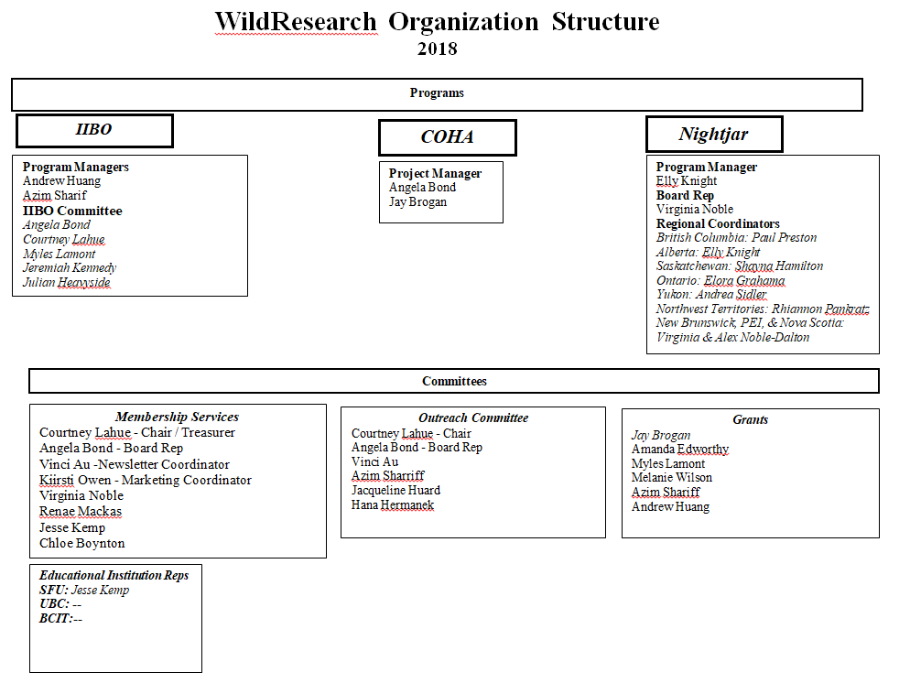

APPENDIX B

WildResearch Treasurer’s Report 2018

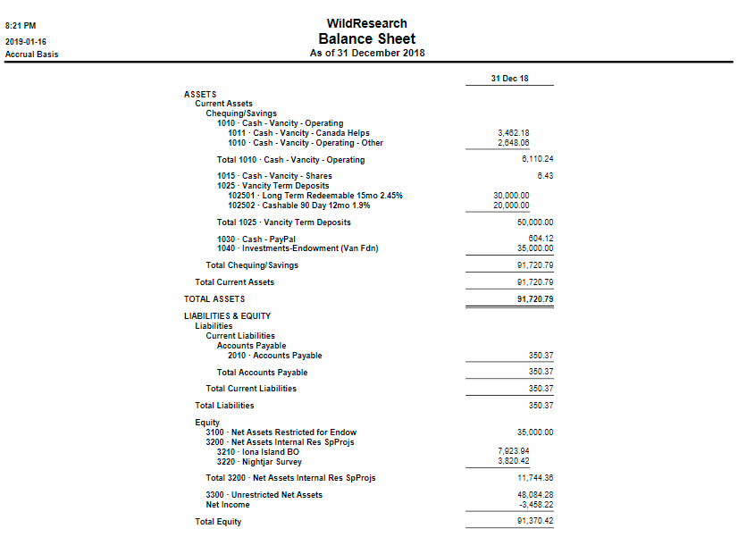

APPENDIX C

WildResearch Iona Island Bird Observatory 2018 Committee Report

WildResearch Iona Island Bird Observatory (IIBO) 2018 Program Update

Program Goals
IIBO contributes to all 3 organizational goals.
- Contribute to conservation science: IIBO determines the abundance and diversity of migrants that use the Iona Beach Regional Park (hereafter: Iona) as a stopover site; IIBO monitors the arrival dates of spring and fall migrants and the departure dates of birds that migrate north to breed or south to overwinter.
- Provide our members with training and education in conservation science: IIBO provides a positive learning environment for volunteers, encouraging the developing of field ornithology skills (e.g. species ID, banding, extraction from nets).
- Conduct conservation outreach: To maintain a focus on public education and outreach on avian conservation via on-site demonstration and social media.

Season successes
- Total # of birds captured: 5706
  - Spring: 2197 (1678 new captures; 429 recaps; 90 unprocessed)
    - Over 44 days (~50 birds per day)
  - Fall: 3509 (2570 new captures; 860 recaps; 79 unprocessed)
    - Over 35 days (~100 birds per day!)
    - In contrast to previous years where we operated 3 days a week for 10 weeks, this is the first year where we operated every day for 6 weeks straight during the fall (end of Aug – beginning of October).
    - Compared to previous years:
      - 2015: 1476 (22 days)
      - 2016: 1232 (22 days)
      - 2017: 2806 (29 days)
- Total # of species captured: 55
  - Spring: 43 species (3 of which have 2 distinct subspecies)
    - Special mention: Northwestern Crow, Northern Saw-whet Owl
  - Fall: 43 species (3 of which have 2 distinct subspecies)
    - Special mention: Virginia Rail, Yellow-headed Blackbird
- Total # of volunteers and volunteer hours: 71 volunteers, 1687 hours
  - Spring: 45 volunteers, 1072 hours
  - Fall: 46 volunteers, 615 hours
- Education & Outreach Program
  - Spring: 268 people, including numerous park visitors, photographers, biologists from the Canadian Wildlife Service and the Canadian Environmental Assessment Agency, Nature Vancouver, UBC Sauder School of Business, Brockhaus Senior Center, Charles Dickens Annex Elementary, Sir Charles Tupper Secondary.
  - Fall: 237 people, including numerous park visitors, photographers, attendees from IOC (Taiwan, Sweden, Japan, Thailand, Germany, Australia), Air Canada (EnRoute Magazine), Patagonia, Metro Vancouver Regional Park, Darren Irwin’s UBC Ornithology class, UBC Wildlife Society, Rockridge Secondary School, and Delta Field Naturalists.
  - Total: 505 people (up from 201 people in 2017).
  - Large part of this due to collaboration with Bird Studies Canada (David Bradley, Catherine Jardine, Kevin Devitt, James Casey, and Zoe Crysler).
- Beginners banding workshop – April 14, 2018
  - We kicked off spring at IIBO with a Bird Banding Workshop on April 14th where 24 keen WildResearch members started the morning at the station learning about the goals and results of bird banding, handling and extracting techniques and how to process birds. The attendees were given an extra special treat with the capture of a Northwestern Crow. Despite their common presence around the station, in the 8 years that IIBO has been operating only 2 have ever been caught due to their intelligence in avoiding the nets and their size and structure which allows them to bounce out of our mist nets. A little bit of luck meant this young, second year, crow hit the net just as one of our banders was approaching during a net check. Though we did not have a large enough band to mark him, it was still quite the experience to get up close and personal with one of the most intelligent and locally successful species at Iona.
- Intermediate banding workshop – Oct 13, 2018
  - On Saturday, October 13th, WildResearch held an intermediate banding workshop. We had a total of 20 participants for this in-class workshop. We are very, very grateful and fortunate to have both Catherine Jardine and Ana Gonzalez (NABC-certified bander) leading the workshop. Both Catherine and Ana are experts in the ornithology field and have been doing bird banding for over a decade. Ana gave an overview of molt theory with plenty of fantastic photographs of wings showing molt limits. Catherine then built on top of Ana's presentation and reviewed the Wolfe-Ryder-Pyle terminologies. Catherine also used Andrew as a model by dressing him up in various outfits - ranging from ragged, wrinkly shirts to fancy flashy suit jacket - all to demonstrate how a bird molts along its migratory route!
  - As part of the workshop, we also had the privilege of using >100 bird specimens, over half of which are warblers. Participants were able to examine each specimen closely as the experts analyzed their wings and molt patterns with them. We would like to thank the Canadian Wildlife Service for providing us with these specimens.
  - Overall, the workshop was engaging, fun, and educational. Many participants expressed that their knowledge prior to the workshop was less complete and more scattered. This workshop streamlined and consolidated their knowledge on molt theory

Season challenges
Things that did not go as well this season:
- Data management as there were multiple banders hired throughout the season.
- Number of volunteer hours went down in fall (by 50%) compared to spring. Reasons unknown – could just be fewer operating days and less hours with open nets.
- Securing funding.
- Hut leaking again.

Suggestions for how program can be approved (in correspondence to the 3 bullet points above):
- Provide clearer instructions, guidance, and overseeing throughout the season to ensure data is managed and entered properly.
- Conduct an analysis on whether fall participation indeed went down; boost advertisement prior to fall starting in 2019.
- Continue to seek funding on all fronts.
- Fix the hut – get Alan involved.

Other things
2018 grants received:
- City of Richmond
- BC Nature
- Canada Summer Job (Service Canada)
- Port of Vancouver

What’s going on in 2019?
- Co-supervision and co-sponsor of an SFU grad student (Master of Science in Ecological Restoration) with Canadian Wildlife Service.
- Plans to hire a UBC grad student to analyze IIBO’s long-term dataset.
- Quinn McCallum (undergrad student from Irwin lab of UBC) will be using IIBO to conduct research on White-crowned and White-throated Sparrow hybridization.

Budget for 2018:
- Approximately $22,000 for hiring banders, purchasing station tools
- Currently we are sitting at around just under $10,000 for IIBO.

APPENDIX D

WildResearch Member’s Services Committee 2018 Report

WildResearch - Members Services Committee Annual Update Report 2018
Chair:
Courtney Lahue
Members:
Courtney Lahue, Chair / Treasurer
Angela Bond, Board Representative
Vinci Au, Newsletter Coordinator
Kiirsti Owen, Marketing Coordinator
Virginia Noble, Member at Large
Renae Mackas, Member at Large
Jesse Kemp, Member at Large
Chloe Boynton, Member at Large

Accomplishments
The MSC oversees membership and membership-related events, merchandise, the newsletter, social media, emails, and thank you cards for the organization. WildResearch’s current membership as of November 2018 stands at 326 active members. Part of our ongoing tasks include recruiting new members and volunteers, processing memberships, reporting progress to BC Nature, polling/surveying about membership satisfaction, tracking MSC financials, scheduling volunteers, and selling WildResearch merchandise.
This year the MSC successfully planned and orchestrated the 2018 AGM in February and is currently planning the 2019 AGM. The MSC also organized volunteers to host our WildResearch booth at the 2018 International Ornithology Congress. We welcomed four new members to our committee, including Vinci, Kiirsti, Jesse and Chloe. We have increased our social media presence with the help of Kiirsti and Vinci and are now reaching out to over 1500 people on Facebook, 800 on Twitter, 500 through Instagram, and 96 on LinkedIn. We have also started an “Age that Bird” contest in our biweekly newsletters and continue to run the #whereswildresearch collection during the summer months to encourage members to sport their WildResearch swag while conducting field work.

Expenses
The total budget allocated to the MSC in 2018 was $3590.00.
Funds in 2018 were allocated to hosting the AGM/VAP and included:
- Venue rental: $200
- Food and drink: $301.60
- Recuperated costs: $15
- Total spent: $486.60
WildResearch successfully solicited donations for the AGM worth approximately $1280 from 16 organizations.
No new merchandise was purchased by November 2018, but the MSC sold merchandise throughout the year and generated $160 in revenue (this number is higher, but we are waiting for an update from the IOC).

Volunteer time
Meetings: 6 hours (3 meetings @ 2 hours each)
2018 AGM planning/prepping outside of meetings: 15 hours
IOC planning/prepping: 60 hours
IOC volunteer hours: ~73 hours
Emails: 156 hours (3 hours/week for 52 weeks)
Processing memberships: 60 hours (3 ho4urs/month)
Total estimated hours: 370 hours

Next Steps
The primary focus of the MSC over the next 3-6 months include planning and executing the 2019 AGM and ordering new merchandise for the organization.

Challenges
Commitment requirements for the MSC remain relatively low overall but come in bursts. At times it can be difficult to plan the AGM while keeping up with other responsibilities including membership, the newsletter, emails, and duties from other committees / Board. However, with the addition of new members to the committee and their valuable organizational skills we can tackle tasks more efficiently and effectively.

APPENDIX E

WildResearch Outreach Committee 2018 Report

WildResearch - Outreach Committee
Annual Update Report 2018
Chair:
Courtney Lahue
Members:
Courtney Lahue, Chair
Angela Bond, Board Representative
Vinci Au, Member at Large
Azim Sharriff, Member at Large
Jacqueline Huard, Member at Large
Hana Hermanek, Member at Large

Accomplishments
The Outreach Committee formed in 2018 to plan, organize and facilitate WildResearch events and workshops. Since forming, the Outreach Committee has assisted in and/or hosted four successful WildResearch workshops, including Resume Writing for Biologists, Beginner Bird Banding, Intermediate Bird Banding, and QGIS, and three seasonal socials at various restaurants in Vancouver.

Expenses
There is no official budget allocated for the Outreach Committee as of November 2018. To date, our workshops have been overseen by the Board and the appropriate funds to secure a venue, food and drink expenses has been allocated as necessary. The average room rental per workshop is approximately $200 (Langara), or is generously donated by AGAT Laboratories, so expenses remain relatively low.

Volunteer time
Meetings: 4 hours (2 meetings @ 2 hours each)
Workshop planning/prepping outside of meetings: 16 hours
Volunteer hours at workshops: 80 hours
Total estimated hours: 100 hours

Next Steps
The Outreach Committee is planning to set up a budget and schedule for upcoming events. We are currently planning a seminar series, trivia pub night, and a movie night for 2019. We are advocating to remain relatively small so we can continue to meet more frequently throughout the year and hope to streamline the planning stages by developing a systematic approach to hosting workshops. Additionally, we may want to consider how we differentiate ourselves from the tasks undertaken by the MSC as there is overlap with some responsibilities (e.g., social media and merchandise could be more Outreach-based tasks than membership-related?).

Challenges
As always, commitment requirements from volunteers to host workshops and events remains trying. There has also been a tendency towards last-minute planning, which is stressful for those organizing the workshops, but may also impact workshop attendance and audience reach.

