MINUTES
WildResearch Annual General Meeting 2021
Date: February 6, 2021
Location: Online
Start: 6:00 PM
In Attendance:
WildResearch Board of Directors: Angela Bond (President), Florian Reurink (Treasurer), Kiirsti Owen (Secretary), Quinn McCallum (Director at Large), Vinci Au (Director at Large), Virginia Noble (Director at Large), Melanie Wilson (Director at Large), Courtney Lahue (Director at Large), Myles Lamont (Director at Large), Jacqueline Huard (MSOC), Colin Macfarlane (MSOC), Chloe Boynton (MSOC), Viktoria Juciūtė (MSOC), Hannah Hall (MSOC), Nisarg Chaudhari (MSOC), Matthias Bieber (IIBO), Miki Eslake (EDI), Siim Karu, Madeline Edmonds, Brendan Toews, Rachel Jacobs, Nigel Peck, Sydney Bliss, Christine Rock, Darren Irwin, Ildiko Szabo, Donna MacKenzie, Alan Mackenzie, Kay Jollymore, Stephen Jollymore, Kelly Sekhon, George Brown, Trisha Beaty, Trina McKinlay

WildResearch Members:

Regrets: Devin DeZwaan (Director at Large), Azim Shariff (Director at Large)

Welcome and introductions – Angela Bond
- Meeting was called to order at 6:00 PM
- Welcome: brief introduction to online format of AGM

Adoption of Agenda – Angela Bond
Motion: to adopt the agenda.
Moved by: Jacqueline Huard
Seconded by: Ildiko Szabo
Decision: Motion carried unanimously

Approval of the minutes from the 2020 agm – Angela Bond
- Available at: http://wildresearch.ca/about-us/resources/
Motion: to approve the WildResearch 2020 AGM Minutes
Moved by: Donna Mackenzie
Seconded by: Jacqueline Huard
Decision: Motion carried unanimously

President’s report
- Presented by President Angela Bond
  - Had to cancel a lot of our programs due to COVID-19, including SMMP (banding only; census went ahead)
  - Programs and events that did go forward had to be altered to deal with COVID-19 restrictions (e.g. online or reduced volunteers)
  - Canadian Nightjar Program officially handed over to Birds Canada
  - Launching new Marsh Monitoring Program this year, collaboration with Birds Canada (starting March 2021)
  - MSOC offered a couple of virtual workshops and events: Gull ID workshop, virtual trivia, Bird Song ID workshop, virtual book club
  - New EDI committee created late last year
  - Western Sandpiper project collaboration with ECCC, would like to continue this project in the future
  - Iona Wastewater Treatment Plant – we are watching these plans closely as they will likely impact IIBO
- See Appendix A for more details

Treasurer’s report
- Presented by Treasurer Florian Reurink
- See Appendix B
Motion: to approve the WildResearch 2020 Treasurer’s Report
Moved by: Ildiko Szabo
Seconded by: Matthias Bieber
Decision: Motion carried unanimously

Committee Reports
- Presented by Committee Chairs: Jacqueline Huard (MSOC), Matthias Bieber (IIBO), Kiirsti Owen (EDI)
- See Appendix C, D, E

Elections
- The following are WildResearch members stepping down from the Board of Directors for 2021:
  - Director at Large: Azim Shariff
- The following are WildResearch members being nominated for the Board of Directors for 2021:
  - Director at Large: Matthias Bieber
- The following are WildResearch members in good standing and are nominated for the positions listed on the Board of Directors for 2021:
  - President: Angela Bond
  - Vice President: -
  - Treasurer: Florian Reurink
  - Secretary: Kiirsti Owen
  - Director at Large: Courtney Lahue
  - Director at Large: Myles Lamont
  - Director at Large: Virginia Noble
  - Director at Large: Vinci Au
  - Director at Large: Melanie Wilson
  - Director at Large: Devin de Zwaan
  - Director at Large: Amanda Edworthy
  - Director at Large: Quinn McCallum
Motion: to approve the 2021 nominations for the WildResearch Board of Directors
Moved by: Darren. Irwin
Seconded by: Kelly Sekhon
Decision: Motion carried unanimously

Adjournment
Motion: to adjourn the 2021 Annual General Meeting
Moved by: Jacqueline Huard
Seconded by: Chloe Boynton
Decision: Motion carried unanimously

Appreciation awards
- Angela recognizes Devin DeZwaan for all of his hard work with the WESA project
- Angela recognizes Myles Lamont for his involvement in the IWWTP
- Kiirsti recognizes Jac for leading MSOC with positivity and inspiration
- Kiirsti recognizes Florian for being Treasurer and for his work in getting the MMP started
- Jac recognizes all of MSOC for their commitment
- Jac recognizes Chloe Boynton for leading the membership manager
- Jac recognizes Kiirsti Owen for her involvement in a variety of tasks in WildResearch
- Jac recognizes Vinci Au for being so dependable, and getting things done
**Note to all members, please keep these new appreciation awards in mind for future years. Any and all members can nominate any other member who deserves recognition for their contributions to WildResearch!**

Please join us after the meeting for our 11th Annual Volunteer Appreciation Party!

APPENDIX A

WildResearch President’s 2020 Report
I know you’ve heard this before but it bears repeating – 2020 was a very different year. WildResearch started the year with a new executive, a few fresh faces on the Board, and a bright outlook for the upcoming year. We had our first ten years behind us and we were ready to hit the ground running for our eleventh year. And then as we all know, Covid hit and changed everything. We had to make several unfortunate cancellation decisions, one right after the other – March pub social evening, annual Cooper’s Hawk Program, Beginner’s Banding Workshop, then for the first time since WildResearch’s inception, our Spring Migration Monitoring banding season at Iona.
It was time to regroup, and I am so proud and appreciative of how our Board and committees worked tirelessly and found ways to adjust; and not only did we remain functional throughout this challenging year, but instead we excelled and kept our members engaged at a time when we could not meet in person. We were able to continue with our mission, which is to “build, train, and educate a community that contributes to conservation science.”
Let’s start by looking at our programs. We did disappointingly cancel our Cooper’s Hawk surveys for 2020. We had a fantastic response from volunteers interested in participating, however the surveys are completed in April which was during the height of the stay-at-home orders, and we wanted to encourage everyone to follow those provincial health guidelines.
Our flagship program, at Iona Island Banding Observatory (IIBO), operated for its eleventh season this year. We were not able to proceed with our spring monitoring banding season due to Covid. That being said, we did perform a daily census survey so we do know what birds were present in the park; and we also did work on vegetation and habitat assessments. We proceeded with our fall monitoring banding season, although things did look a little different this year. We had to put several Covid-related safety protocols in place, which included not being able to do hands-on training of new volunteers. Despite these restrictions, we had a successful season. We added a new daily shift for the census, which we plan to continue doing going forward. We were able to open our nets 42 days between August 26 and October 6, and we banded 2281 individual birds (1894 new and 387 recaptures); representing 48 species. Some of the highlights include a Northern Waterthrush, a Pine Siskin, a Sharp-shinned Hawk, our first ever Clay-coloured Sparrow, and a Northern Mockingbird right at the end of the season. A huge thank you to this season’s two Banders-in-Charge Brendan Toews and Amanda Edworthy, two Assistant Banders Kristen Mancuso and Maddie Edmonds, and our two Program Co-Managers Matthias Bieber and Azim Shariff.
2020 was the first year the Nightjar Program was officially coordinated by Birds Canada after we handed over the reins at the beginning of the year. Our final annual report for 2019 is available on our website. To help fill this void, we are very excited to be launching our new program this spring – our Marsh Monitoring Program in collaboration with Birds Canada. This involves a standardized protocol for point counts of birds and amphibians in marshes throughout the lower mainland. We are diligently working on the set-up now, and you can look forward to workshops in the very near future followed by the project kick-off in early spring. Many thanks to Florian Reurink for taking the lead on this.
Our Membership Services and Outreach Committee (MSOC) has remained quite active throughout the year, providing numerous events and activities to keep our members engaged. We offered our first ever virtual workshop in April when we had Joachim Bertrands teach us all about Gull ID. We then held a super fun and successful virtual Trivia Night, and in July our very own Kiirsti Owens and Colin Macfarlane provided a Bird Song ID Workshop which was both educational and entertaining. We were also quite pleased to introduce a new piece of fashionable yet practical merchandise – our new buff. A must-have for everyone! WildResearch also provided another first – an online book club. Participants read “What the Robin Knows” by Jon Young and met online weekly to discuss; ending with a physically distanced bird walk. I’d like to give big thanks to Vinci Au for organizing the book club and to Jacqueline Huard for continuing to lead the MSOC.
In response to the rise of the Black Lives Matter movement, we felt it was important to pause and look for ways we, as an organization, can be more inclusive. In June, the Board released an official statement on Diversity, Equity, Inclusion, and Anti-Racism. We formed a DEI Committee to help find ways to address anti-racism and inclusion in our community. All Board members, as well as committee and program leaders, are taking a Diversity and Inclusion Training for Volunteers course to help raise awareness and be informed. Many thanks to Kiirsti Owens for taking the lead on this DEI committee.
WildResearch undertook an exciting collaborative project with Environment Canada and Climate Change (ECCC) this past summer. Using mist nets out on the mudflats, Western Sandpipers were captured, processed, and banded; and nanotags deployed. Forty-six nanotags were deployed at our sites in Roberts Bank and the other thirty-three at Iona Island Regional Park. There was little opportunity for volunteering due to Covid, but we hope to continue this project for the next few years and there should be more volunteering opportunities as the Covid situation improves. In conjunction with this project, Brendan Toews completed shorebird surveys at Roberts Bank and Iona every week, and volunteers were welcome to participate with him in these. A really big thank you goes to Devin de Zwaan for all of his organizational work in setting up the WESA project for us; and to Eveling Tavera Fernandez for being the project lead / Bander in Charge.
Looking forward, we are watching with keen interest the upcoming changes to the Iona Wastewater Treatment Plant. The treatment plant is doing a complete overhaul, and as part of this there are huge changes coming to the Iona park itself. These will certainly be affecting our banding operations, which makes us a major stakeholder in this process. We have been participating in stakeholder meetings, Metro Vancouver committee meetings, and submitted a detailed report outlining our suggestions and recommendations. This could be an incredible opportunity for research projects, collaborative opportunities, funding opportunities from their mitigation fund, and other outreach and educational prospects. Stay tuned for updates as this unfolds, and a huge thank you goes to Myles Lamont for representing us at meetings and generating our recommendation report.
And with that, I’d like to sign off by saying how proud I am of what we were able to accomplish during such a challenging year – during a year when we couldn’t even meet in person. Even though we are still under the restrictions of this pandemic, I see a positive, busy, and bright year ahead of us. We have our new Marsh Monitoring Program kicking off and our MSOC has things scheduled to promote every month. I would like to give a big thank you to Azim Shariff, who is stepping down from the Board of Directors this year, as I am grateful for all of his contributions. I am pleased to be welcoming a new incoming Board Member, Director at Large Matthias Bieber, and look forward having him on our team. And most of all, thank you to all our members – we couldn’t do this without you!

APPENDIX B

WildResearch Treasurer’s Report of 2020 Finance
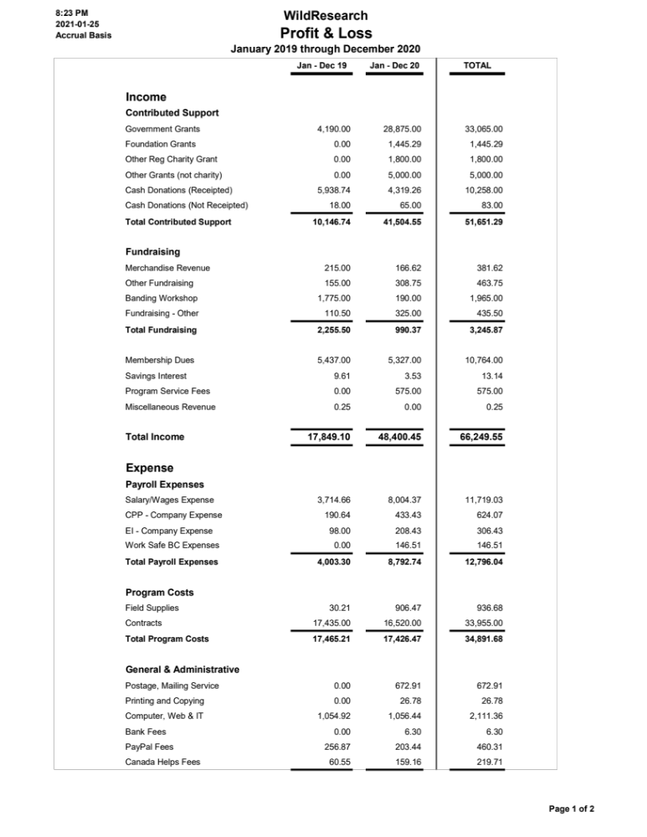
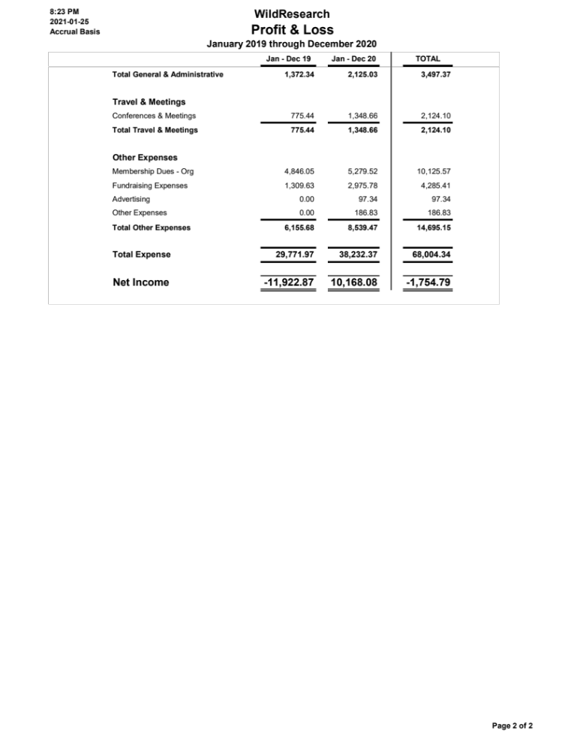

APPENDIX C

WildResearch Iona Island Bird Observatory 2020 Report

Program Goals
IIBO contributes to all 3 organizational goals.
- Contribute to conservation science: IIBO determines the abundance and diversity of migrants that use the Iona Beach Regional Park (hereafter: Iona) as a stopover site; IIBO monitors the arrival dates of spring and fall migrants and the departure dates of birds that migrate north to breed or south to overwinter.
- Provide our members with training and education in conservation science: IIBO provides a positive learning environment for volunteers, encouraging the developing of field ornithology skills (e.g. species ID, banding, extraction from nets).
- Conduct conservation outreach: To maintain a focus on public education and outreach on avian conservation via on-site demonstration and social media.

Season successes
Breakdown of # of species and individuals caught
Total # of birds captured:
- Spring
  - Banding season canceled due to COVID-19 but still conducted daily census
- Fall:
  - 2272 (1895 new captures; 377 recaps; 20 unprocessed)
  - Over 37 days (5 weather days), 2234 net hours
    - ~61 birds/day
    - 1.03 birds/net hr
  - Compared to previous years:
    - 2015: 1476 (22 days) – 0.35 birds/net hr
    - 2016: 1232 (22 days) – 1.05 birds/net hr
    - 2017: 2806 (29 days) – 1.12 birds/net hr
    - 2018: 3509 (35 days) – 0.95 birds/net hr
    - 2019: 4192 (38 days) – 2.02 birds/net hr
Total # of species captured: 48
- Most abundant banded:
  - YEWA: 548
  - OCWA: 146
  - RCKI: 138
  - SOSP: 115
  - Interesting highlights
    - Rarities: NOMO (first ever!), DUFL, CCSP, NOWA
    - Also PISI, BUSH, VATH (more common but rarely captured)
Breakdown of volunteer contribution and visitors
Total # of volunteers and volunteer hours: 23 volunteers, 323.5 hours
- Fall: 23 volunteers, 55 volunteer days, 323.5 hours
- About half the number of volunteer totals from 2018 & 2019
Education & Outreach Program
- Total: 248 people visited IIBO
  - Substantial decrease compared to 2019 (961 but over two seasons)
- Groups: 5 bird walks for Vancouver Bird Week (limited to 6 ppl) and Wings Over Iona
- Decrease in numbers due to COVID-19. Groups had to be limited to 6 ppl, no school groups or nature clubs and we discouraged visitors from interacting with banding operations.

Banding Workshops – Canceled in 2020

Other Exciting Things
CWS Collaboration: Feather collection for stable isotope analysis
- Investigating breeding origins of species that experience high window collision mortality during migration and in winter in SW BC
  - FOSP, GCSP, SOSP, HETH, WCSP
- Through this IIBO is helping to increase understanding of migratory connectivity between breeding and non-breeding populations for these species, and the contribution of winter mortality to their declines
Shorebird Banding Collaboration with ECCC
- IIBO bander, Brendan Toews helped capture and apply nanotags to Western Sandpipers on Iona Beach and Roberts Bank in July and August. IIBO also lent equipment for this.
Habitat Monitoring for IIBO’s Canadian Migration Monitoring Network (CMMN) membership
- A habitat assessment protocol was completed and first official habitat assessment conducted during the summer

Season challenges
- Banding with COVID – loss of spring banding season
  - Not enough intermediate/advanced volunteers
- Hut still leaking
- Managing band inventory during permit transfer

Suggestions for how program can be approved (in correspondence to the 3 bullet points above):
- More advertisement on social media, email reminders to skilled volunteers
- Fix the hut – get Alan involved.
- Keep closer track of inventory: go through physical bands and make list of what we have
  - Consolidate with digital inventory

Other things

2020 grants received:
- Canada Summer Jobs (Service Canada) – $9041.40
- Port of Vancouver (Vancouver Fraser Port Authority) - $5000
- BC Nature - $1800

What’s going on in 2021?
- Hoping to bring back both banding seasons and banding workshops
- More feather sample collection for UCLA’s Genoscape Project

Budget for 2020
- Approximately $17,000 for hiring banders (including habitat work), and purchasing cleaning equipment

APPENDIX D

WildResearch Member’s Services Committee Report 2020 report

10 Members:
Jacqueline Huard, Chair/Treasurer
Angela Bond, Board Representative*
Azim Shariff, Board Representative
Vinci Au, Newsletter Coordinator, Social Media Contributor, Board Representative
Kiirsti Owen, Social Media Contributor, Board Representative*
Chloe Boynton, Membership Coordinator,
James Mackenzie, Instagram Coordinator, Facebook Contributor
Colin Macfarlane, Newsletter Coordinator, Member at Large
Cassandra Holt, Website Manager*
Viktorija Juciūtė , Newsletter Contributor, Membership Coordinator, Member at Large
Nisarg Chaudhari, Newsletter Contributor, Member at Large
Hannah Hall, Member at Large
Jesse Kemp, Member at Large
Virginia Noble, Member at Large

*stepped down part way through the year

Sadly, we said good bye to Angela and Kiirsti as they took on more board member duties. We welcomed five new members to our committee, Cassandra Holt (who has since left and gone back to Australia), Colin Macfarlane, Viktorija Juciūtė, Nisarg Chaudhari, and Hannah Hall.

Committee Purpose
The Membership Services and Outreach Committee (MSOC) is all about the members! We manage the administration of members, and events for members. WildResearch’s current membership as of December 2020 stands at 216 active members.

The MSOC oversees:
- Membership (registration, payment, insurance),
- Organizing the AGM & the Volunteer Appreciation Party (VAP),
- Merchandise,
- Fundraising,
- Committee finance planning & tracking,
- Outreach and general advertising,
- Newsletter production,
- Social media management and posting,
- Some e-mails/contact liaisons with members, and
- Planning, organizing and facilitating official WildResearch events and workshops.

Previously this committee was composed of two sub committees, the Outreach Committee and the Membership Services Committee. In 2019, they were joined together and are now known as the Membership Services and Outreach Committee (MSOC).

2020 Committee Accomplishments
AGM
Similar to past years, the MSC successfully planned and orchestrated the previous AGM (2020) in February at VanDusen Gardens and is currently planning the next AGM (Feb 6, 2021), our first digital AGM.
Outreach
- Newsletter – This year we produced 33 newsletters with the help of 8 creators. Each newsletter requires 2 people to produce. Particular credit goes to Vinci Au who leads the Newsletter team whose experience carries us along and she has contributed to almost half of the newsletters, as well as to new team member Colin Macfarlane who also contributed to a significant number of the newsletters.

- Social Media – our presence has continued to increase with the ongoing help of James, Kiirsti and Vinci. We are now reaching:
  - Facebook: 1,844 Followers/1,707 likes
  - Twitter: 1,140 Followers;
  - LinkedIn: 168 Followers; and
  - Instagram: 1602;
    - Instagram has good participation, stories get between 180-300 (up from 160-190) views, an average reach of 750 people with a high of 1,312, comments average 0-3 and key comments garner 6-10 comments. Stories generally receive greater engagement and over 60 votes in the bird quizzes. Big thanks to James, his great photography skills and time spent on Instagram and his ballooning birding skills! One area for improvement noted by James was that advertisements for events on Instagram do get attention but due to their word-heavy content tend to have fewer likes and would be improved with high quality photos.

- University Students - We created a plan to visit UBC classrooms. We successfully visited one and distributed stickers & magnets, however COVID interrupted our intentions. (4 Hours)

- Past/unrenewed members – We reached out to past members this year, however it was not met with strong results and we don’t recommend using this technique in the future. This effort was lead by Chloe and Viktoija. (5 hours)

- Website Improvements – We were very lucky to have Cassandra Holt join the MSOC mid-year. She (and with help from her partner Nathan) spent a lot of time and effort helping with the website. (8 hours)

- Posters - James created 6 gorgeous posters and had 200 (total) printed for distribution at public locations. Due to COVID we have held off on posting these. They are currently with Viktorija and we hope to run a posting campaign to get them posted in the spring.
Events
We held 14 events this year!! And would have held more except that several were cancelled due to COVID.
- 2019/2020 Guided Bird Walks (3)
- Granville Island Social
- Big Rock Brewery Social March 26th (Covid Cancelled)
- Owl Call Playback surveys (Covid Cancelled)
  - Ladner
  - South Surrey
- Gull ID Workshop by Joachim Bertrands April 30th(>50 attendees)
- Vinci started our first Book Club! Started in June
  - And an associated Bird Walk at UBC botanical Gardens
- Global Big Day May 9th
- Doors Open Richmond June 6th-13th
- Birding By Ear Workshop by Kiirsti & Colin July 9th (>40 attendees)
- Marine Mammals Workshop by Jacklyn Barrs (10 attendees)
- Wings Over Iona August – Sept 19th
- Digital Trivia June 4th (7 teams, 25 ppl attended)
- Vancouver Bird Week Oct 3-10th
- Monthly Bird ID Trips 2020/2021 (all COVID Cancelled thus far)

Volunteer time – 459 hours
This year due to the numerous events we facilitated, we hosted a meeting every month, doubling our full group meetings from 6 in 2019 to 12 in 2020, and several smaller group meetings were held to organize specific events.
Meetings: 216 hours (up from 60) (12 meetings @ 2 hours each with ~ 9 people)
Non-meeting Outreach planning/organizing/delivering: ~50 hours
AGM planning/prepping outside of meetings: 25 hours
Newsletter: 132 hours (2 hours/week for 33 weeks * 2 people)
Processing memberships: 36 hours (1.5 hours/month * 2 people)
Total estimated hours: 459 hours (up from 250)

FinAnces
We successfully raised over $5,056 this year and spent only $97.34.
The total budget allocated to the MSC in 2020 was $1,700.00, however 2020 presented an unusual spending year as COVID-19 restricted our ability to come together and therefore the need to rent space and supplies was not needed.
Total Spent: $-97.34
- Venue rental: $0
- Food and drink: $0
- Poster Printing: $-97.34
Recuperated costs: $5,056
- Seminar Series talks:
- Merchandise: $1,060 (up from $206 in 2019)
- Brown Creeper/Giving Tuesday/general donations: $3,996
In addition to our existing inventory new mugs and buffs arrived early last year. We updated the photos on the website and made a concerted effort to advertise when opening our events. As our stock dwindles we will need to consider new orders.

Next Steps
The primary focus of the MSC over the next 12 months include planning and executing the 2020 AGM and planning our spring events (See Table 1 below).
Table 1: Proposed 2021 WildResearch Events
Month | Count | Events
Jan | 1 | Guided Bird Walks (cancelled)
Feb | 4 | Guided Bird Walks, AGM/Speaker/Trivia, Intro to Marsh Monitoring, Backyard Bird Count
March | 5 | Guided Bird Walks, Raptor Talk (Joachim), Marsh Monitoring, Seedy Saturday
April | 2 | Spring Banding, Photography Workshop with James, MMP, Cooper’s Hawk MP
May | 3 | Spring Banding, Getting into Grad School Jacob (flexible), Global Big Day, Skagit Bird Blitz, MMP
June | 2 | Birding by Ear (by Kiirsti & Colin), Doors Open Richmond, Manning Bird Blitz, MMP, Joachim workshop (shorebirds), MMP
July | 1 | Nighthawk Surveys, Western Sandpiper Monitoring Program, MMP
Aug | 2 | Western Sandpiper Monitoring Program, Wings-Over-Iona
Sept | 1 | Fall Banding
Oct | 2 | Fall Banding, Vancouver Bird Week
Nov | 0/1 | Trivia/Repeat Gull ID (Joachim) Or maybe a break as our schedule is PACKED
Dec | 2 | Giving Tuesday, CBC
Total | 25/26 events!!

Challenges
Commitment requirements for the MSC have increased. At times it can be difficult to plan the AGM while keeping up with other responsibilities including membership, the newsletter, emails, and duties from other committees/Board. This year we have had new members join and throughout the year we have settled into an organized and efficient structure.
As always, we are looking for additional members to distribute the work and gain new and diverse perspectives. To join please email Jac at jachuard@gmail.com (or talk to any of the MSOC members).

APPENDIX E

WildResearch Equity, Diversity, and Inclusion Committee 2020 Report
Current members: Kiirsti Owen, Miki Eslake, Kim Dohms

Committee created in October 2020, meeting once monthly

In response to many events last year both in the states but also here in Canada, many organizations released statements regarding racism, and issues of equity, diversity, and inclusion. WildResearch too decided to release our own statement, which you can find on our website, and as a board, we decided that all board members and program leads will now be required to take diversity and inclusion training.

The incident in Central Park where a Black birder had the cops called on him by a white woman, and actually a similar incident occurred very close to our banding station a few years ago… these events makes it clear that there are barriers to participating in birdwatching and community science. So as a board, we decided we would take an additional step and create a new committee: the Equity, Diversity, and Inclusion committee. We hope to make not only WildResearch but also the conservation science and birding communities more accessible so that anyone who wants to be a part of WildResearch or these communities can be.

We're still a very new committee with only three members, but we're excited to see what we can accomplish. We're also interested in adding one or two more members to this committee, so if anyone is interested, please send an email to the info@wildresearch.ca account. You don't have to identify as being part of a minority group to join, you just have to be keen. Thanks, and I hope the EDI committee will have a list of achievements to share with you at the next AGM!

